**SPRINT 4**

|  |  |
| --- | --- |
| Date | 19 November 2022 |
| Team ID | PNT2022TMID26330 |
| Project Name | Smart Farmer – IoT Enabled Farming Application |
| Maximum Marks | 8 Marks |

**Node-RED Service Creation in IBM Cloud:**

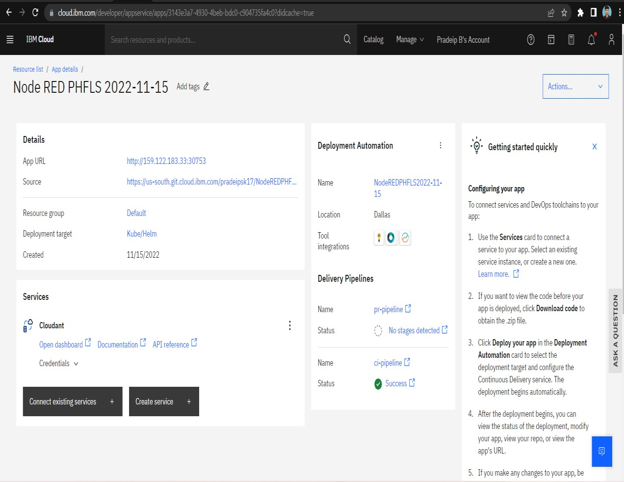

Node-RED service was created in the IBM cloud. After establishing Node-RED service, IBMIoT was installed in the Node-RED platform. Then, IBM Watson IoT platform was connected with Node-RED and the values in the IBM Watson IoT platform gets updated to the Node-RED in json file format.

**Node-RED flow for getting sensor values from IBM Watson IoT Platform:**

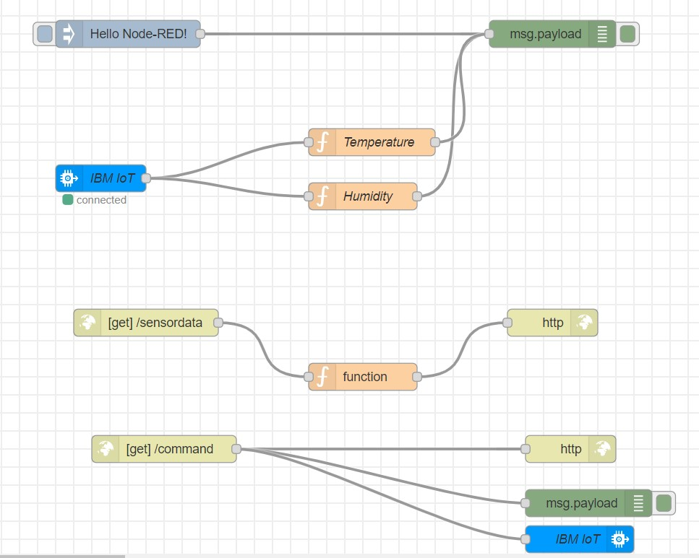

**Node-RED Flow Node-RED debug window:**

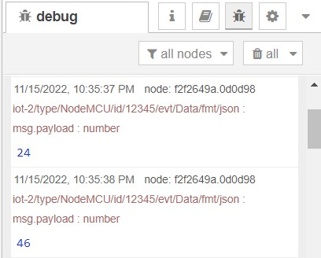

Temperature and Humidity values from the Wokwi simulator gets updated in the debug window of the Node-RED in the json file format.

**Displaying Temperature and Humidity values over the URL using http response:**

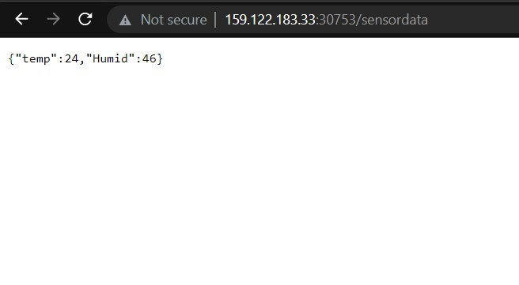

**MIT App inventor Front End:**

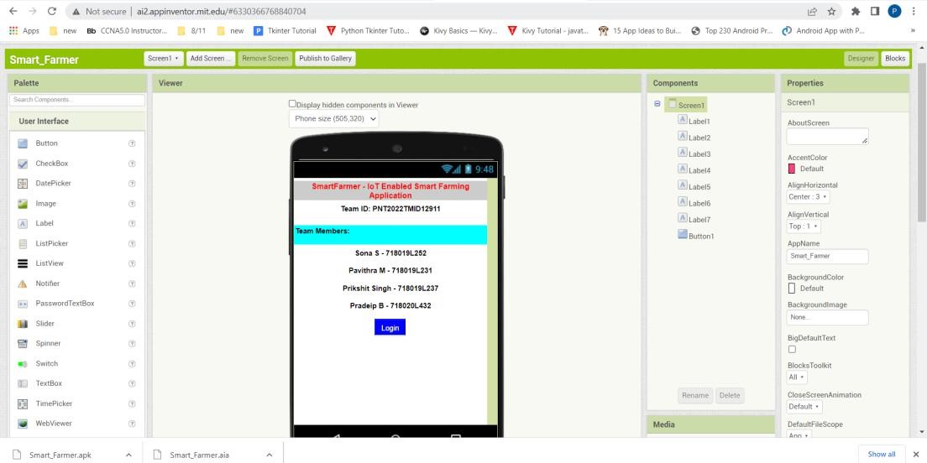

**Screen 1**

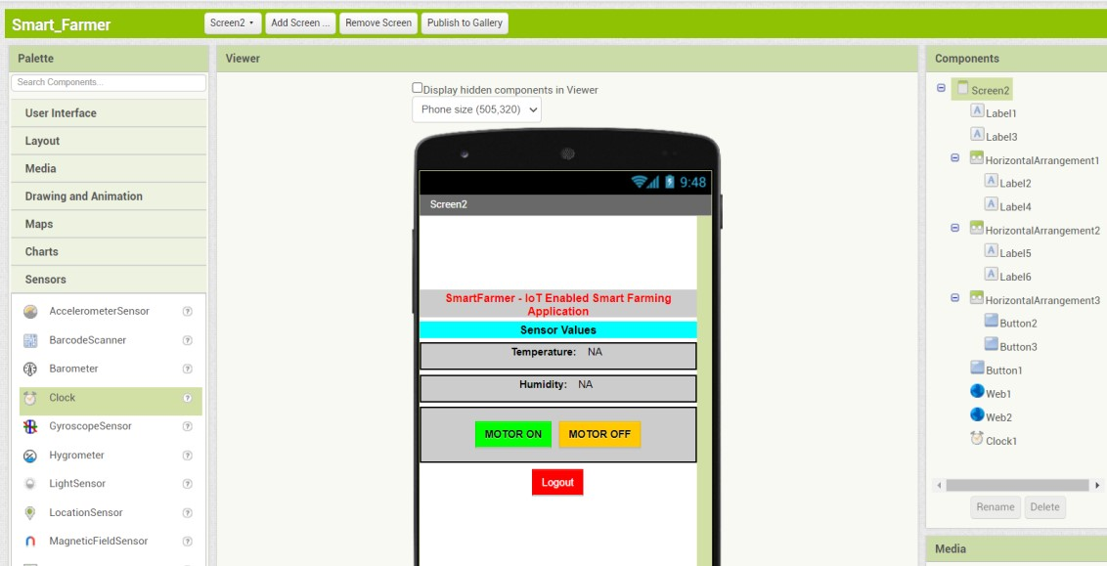

**Screen 2**

**MIT App Inventor Back end:**

**Screen 1**

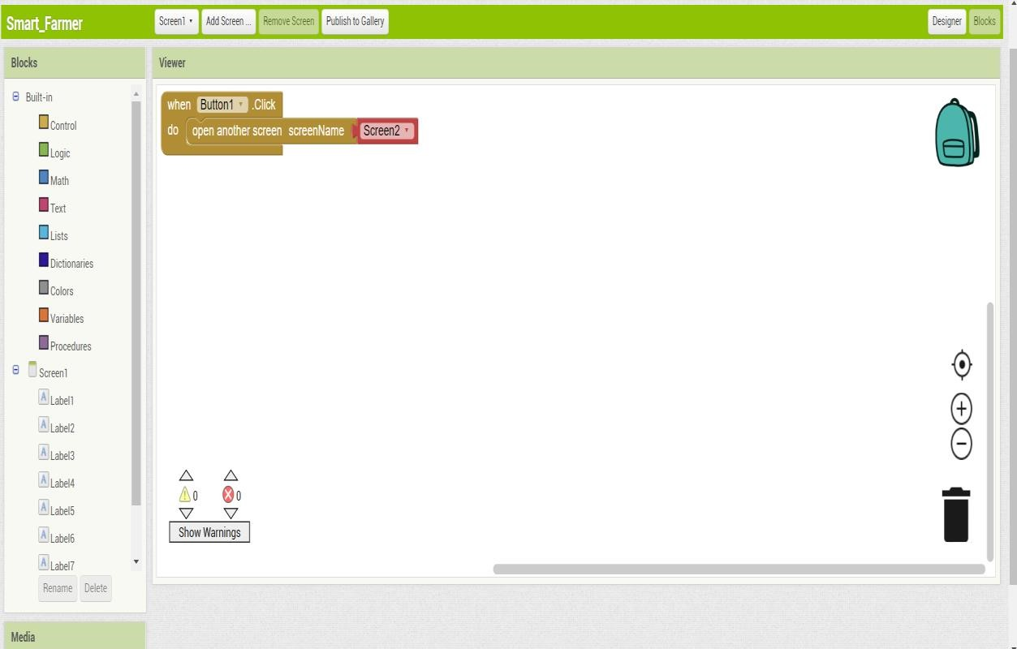

**Screen**

**2**

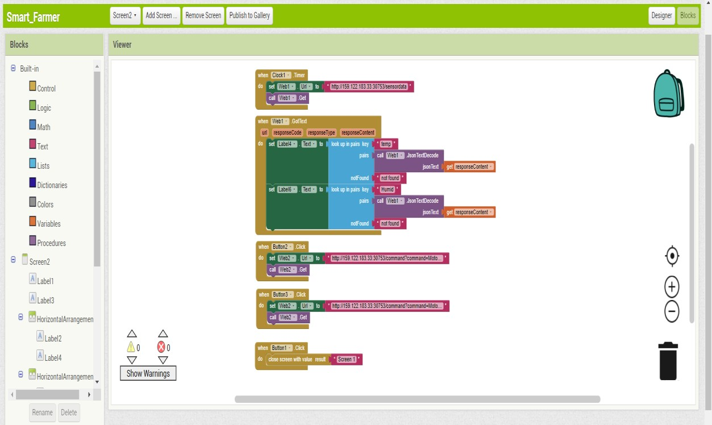

**Exporting APK File:**

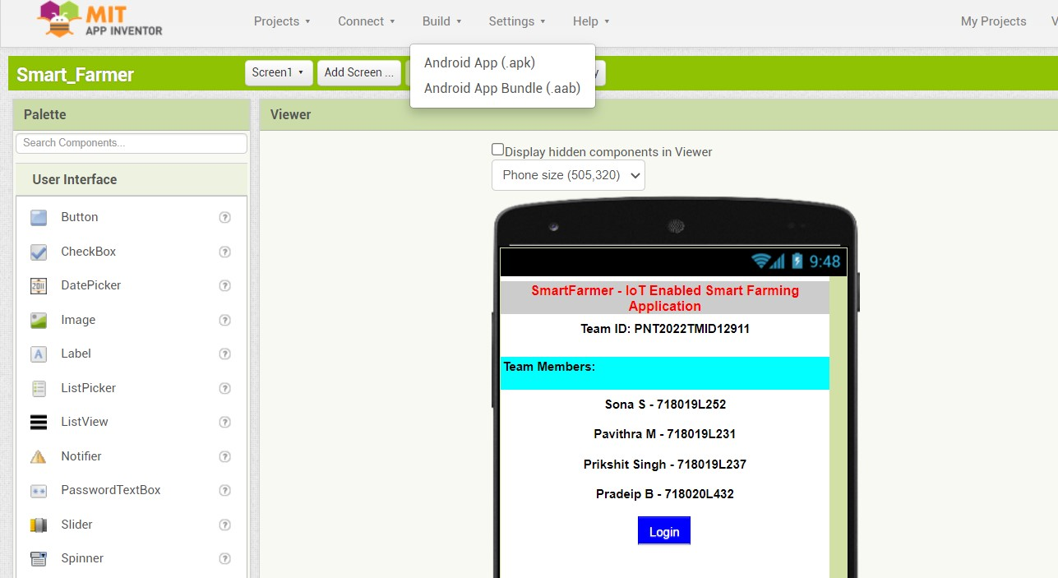

**Generated APK file:**



**Size of the APK file:** 3.5 MB

Once the apk file was generated, It can be installed in our mobile phones. After installing mobile application, senor data like temperature and humidity will be updated to the mobile phone dashboard through Node-RED http request method.

Based on the temperature and humidity value, user can switch on/off the motor using the Motor On/OFF button in the screen 2.

**Mobile Application:**

**Screen 1**

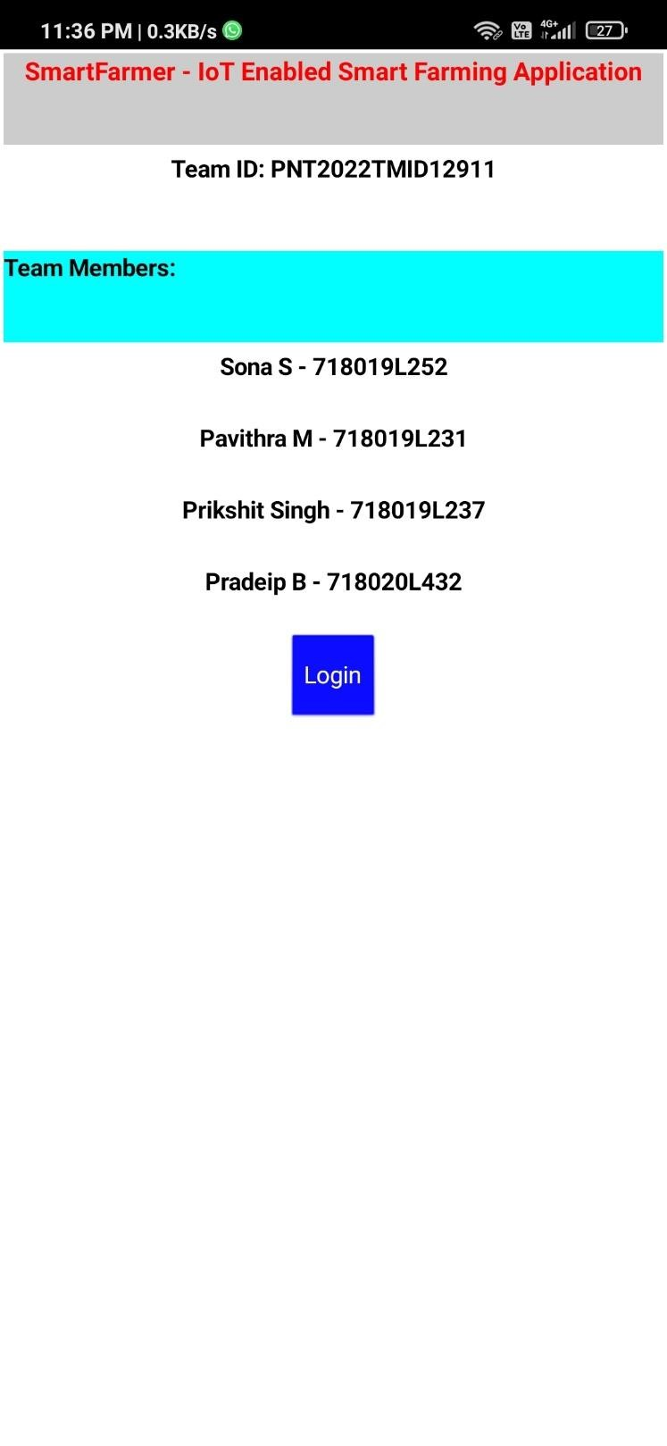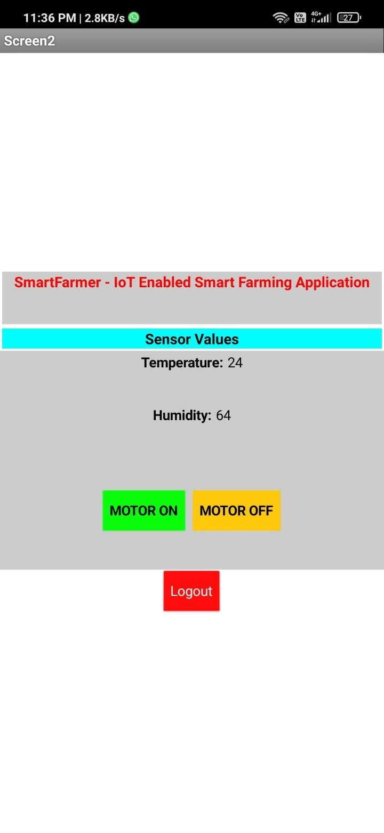

**Screen 2**

**Pressing Motor ON Switch:**

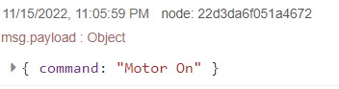

If Motor On switch is pressed by the user, Motor On message will be received by the Node-RED tool. Then, the message will be updated to the IBM Watson IoT Platform.

**Pressing Motor ON Switch:**

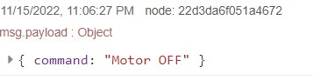

If Motor OFF switch is pressed by the user, Motor OFF message will be received by the Node-RED tool. Then, the message will be updated to the IBM Watson IoT Platform.